

SHIVNAGAR VIDYA PRASARAK MANDAL’S

**COLLEGE OF COMMERCE, SCIENCE AND COMPUTEREDUCATION**

MALEGAON (BK), TALUKA-BARAMATI, DIST.-PUNE, PIN-413115.

PROJECT REPORT

SUBMITTED IN PARTIAL FULFILLMENT OF THE REQUIREMENTS FOR THE AWARD OF THE DEGREE IN BACHELOR OF BUSSINESS ADMINISTRATION (COMPUTER APPLICATION) (FORMERLY KNOWN AS BCA)

OF

**SAVITRIBAI PHULE PUNE UNIVERSITY,  
PUNE.**

ON  
**“ONLINE FOOD ORDERING SYSTEM.”**

BY  
**PATIL PRATIK MAHADEV**

**ADAGLE SHUBHAM SHUBHASH**

UNDER THE GUIDANCE OF   
**PROF. BANDGAR S.H.**

**TYBBA(CA) (SEM – V)**

*(Formerly Known as BCA)* **2021-2022.**

SVPM’s

College of Commerce, Science and Computer Education,

**Malegaon (Bk) - 413 115, Tal - Baramati, Dist. - Pune.**

(Approved by AICTE New Delhi,Govt. of Maharashtra &Affilated to University of Pune)

Ph: (02112) 254388, Website: www.svpm.org.in

CERTIFICATE

**BBA(CA) PROGRAMME (Formerly Known as BCA)2021 - 2022**

This is to certify that the Project Report on

**“ONLINE FOOD ORDERING SYSTEM.”**

Submitted by

**MR. PATIL PRATIK MAHADEV**

Has successfully submitted during the academic year 2021-2022, in the partial fulfillment of the Bachelor of Business Administrator (Computer Application) BBA(CA)(SEM–V) (Formerly Known as BCA) Degree programmed under Savitribai Phule Pune University, Pune.

Project Guide Principal

Internal Examiner External Examiner

**INDEX**

|  |  |  |
| --- | --- | --- |
| **SR.NO.** | **CONTENTS** | **PAGE NO.** |
| **1** | **Abstract** |  |
| **2** | **Introduction** |  |
|  | 1. Motivation |  |
|  | 1. Problem Statement |  |
|  | 1. Purpose/Objective and goals |  |
|  | 1. Literature Survey |  |
|  | 1. Project Scope and Limitations |  |
| **3** | **System Analysis** |  |
|  | 1. Existing systems |  |
|  | 1. Scope and Limitations of Existing Systems |  |
|  | 1. Project Perspective, Features |  |
|  | 1. Stakeholders |  |
|  | 1. Requirement analysis 2. Functional Requirements 3. Performance Requirements 4. Security Requirements |  |
| **4** | **System Design** |  |
|  | 1. Design constraints. |  |
|  | 1. System Model: DFD |  |
|  | 1. Data Model |  |
|  | 1. User Interfaces |  |
| **5** | **Implementation details** |  |
|  | Software/hardware specifications |  |
| **6** | **Outputs and Reports Testing** |  |
|  | 1. Test Plan. |  |
|  | 1. Black Box Testing or Data Validation Test Cases. |  |
|  | 1. White Box Testing or Functional Validation Test Cases and results |  |
| **7** | **Conclusion and Recommendations** |  |
| **8** | **Future Scope** |  |
| **9** | **Bibliography and References.** |  |

ONLINE FOOD ORDERING SYSTEM

**ABSTRACT**

Online Food Ordering System is proposed for simplifies the food ordering process. This

System shows a user interface and update the menu with all available options so that it eases the customer work. Customer can choose more than one item to make an order and can view Order details before logging off. The order confirmation is sent to the customer. The order is placed in the queue and updated in the Database and returned in real time. This system assists the staff to go through the orders in real time and process it efficiently. Online food order system is mainly designed primarily function for use in the food delivery industry. This system will allow hotels and restaurants to increase online food ordering such type of business. The customers can be selected food menu items just few minutes. In the modern food industries allows to quickly and easily delivery on customer place. Restaurant employees then use these orders through an easy to delivery on customer place easy find out navigate graphical interface for efficient processing.

**INTRODUCTION**

The [Online Ordering System](http://www.nibblematrix.com/) can be defined as a simple and convenient way for customers to purchase food online, without having to go to the restaurant.

This system is enabled by the internet – it is the internet that connects the restaurant or the food company on one hand, and the customer on other hand.

Therefore, as per this system, the customer visits the restaurant’s website, browses through the various food items available there and goes ahead and selects and purchases the items he or she needs.

These items will then be delivered to the customer at his or her doorstep at the time they choose by a delivery person.

Payments for such online orders can be made through debit cards, credit cards, cash or card on delivery, or even through digital wallets.

This system for online food delivery is completely safe, secure and is a very popular method that is revolutionizing the way in which the food industry operates.

Here we Propose an “Online Food Ordering System” that has been Designed for Fast Food restaurant, Take-Out or College Cafeterias. The system can also be used in any food delivery industry. This simplifies the process of food ordering for both the customer and the restaurant, as the entire process of taking orders is automated.

The main advantage of my system is that it greatly simplifies the ordering process for both the customer and the restaurant. When the customer visits the ordering webpage, they are presented with an interactive and up-to-date menu, complete with all available options and dynamically adjusting prices based on the selected options. After making a selection, the item is then added to their order, which the customer can review the details of at any time before checking out. This provides instant visual confirmation of what was selected

**MOTIVATION**

The motivation for designing this application came because my family is involved in the fast-food business and I personally do not like waiting for long in the store or to have to call store to place an order especially during the peak lunch or dinner hours. Moreover, I value recent learning about the php Programming languages as well as seeing how powerful and dynamic they are when it comes to web designing and applications. whereas MySQL database at the back-end because I found them to be extremely useful while working on the technologies.

This system specifically e made for or following issues

1. It reduces manual work.
2. The online food delivery system is overcome the problems in manual system.
3. This system is fully computerized.
4. It is user friendly.
5. Provide quickly reports.
6. Highly efficient and accurate.
7. Prevention of unauthorized access of data.
8. Automated.

**PROBLEM STATEMENTS**

1. Some of the major problems reported by the customers surveyed revolved around late deliveries because of network problem
2. Incorrect orders being delivered due to communication problem.
3. Orders not being delivered at all, rude customer service.
4. Cold food being delivered, and the driver requiring a lot of guidance to find the delivery location.
5. Sometime payment issue is occurred.
6. Online food ordering system service now days increase your budget.
7. lack of a visual confirmation that the order was placed correctly.

**PURPOSE OR OBJECTIVES AND GOALS**

**PURPOSE**

The proposed system is developed to manage ordering activities in fast food restaurant. It helps to record customer submitted orders. The system should cover the following functions in order to support the restaurant’s business process for achieving the objectives:

1. To allow the customer to make order, view order and make changes before submitting their order and allow them make payment through prepayment card or credit card or debit card.

2. To provide interface that allows promotion and menu.

3. To prevent interface that shows customers’ orders detail to front-end and kitchen staffs for delivering customers’ orders

4. Tools that generate reports that can be used for decision making

5. A tool that allows the management to modify the food information such as price, add a new menu and many others as well as tools for managing user, system menu and promotion records.

This will minimize the number of employees at the back of the counter.

The system will help to reduce labor cost involved.

The system will be less probable to make mistake, since it’s a machine.

This will avoid long queues at the counter due to the speed of execution and number of optimum screens to accommodate the maximum throughput.

**OBJECTIVES AND GOALS**

1. To increase efficiency and improve services provided to the customers through better application of technology in daily operations.
2. To be able to stand out from competitors in the food service industry
3. To enable customers to order custom meals that aren’t in the menu
4. To enable customers to have a visual confirmation that the order was placed correctly
5. To enable customers to know food ingredients before ordering
6. To reduce restaurant’s food wastage
7. To ensure correct placement of orders through visual confirmation
8. Improve efficiency of restaurant’s staff
9. Eliminate paper work and increase level of accuracy
10. Increase speed of service, sales volume and customer satisfaction
11. To increase efficiency by shortening the purchasing time and eliminating paper work like receipts through online transaction
12. To be able to stand out from competitors by automating daily operations which will give food service providers the opportunity to increase sales
13. To reduce restaurants food wastage and increasing efficiency of the restaurants staff by enabling the restaurants staff to know what food items the customers wanting advance.
14. To increase customer satisfaction by speeding up food delivery
15. To reduce time wasting by eliminating long queues
16. More accuracy and easy order processing.

**LITERATURE SURVEY**

Various case studies have highlighted the problems faced While setting up a restaurant. Some of the problems Found during the survey in the existing system are listed Below:

1. To place the orders customer visits the restaurant, Checks the menu items available in the restaurant, and chooses the items required, then places the order and then do the payment.
2. This method demands Manual work and time on the part of the customer.
3. When the customer wants to order over the phone, Customer is unable to see the physical copy of the Menu available in the restaurant, this also lacks the Verification that the order was placed for the appropriate menu items.
4. Every restaurant needs someone or the other to take order personally or over phone, to offer the Customer a rich experience and even to process the payment.

**PROJECT SCOPE AND LIMITATION**

**SCOPE OF SYSTEM**

1. This system will help to customer and administrator for the ordering process.
2. To manage the details of Item Category, Food, Delivery Address, Order, Shopping Cart. ...
3. Easy to make ordering and hopefully can smoothen up the job of administrator and waiter.
4. This system produces a computerized system in defining the best solution in food delivery system.
5. Easy access to any stage.
6. Lot of time is saved.
7. Easy back up of data.

**LIMITATIONS**

1. Cost associated with backup storage to the system than the cost associate with maintaining on-site alone.
2. A potential for customer to fail to adapt to online ordering or table site checkout.

**EXISTING SYSTEM**

1. The existing system happens to be a non-computerized operating system.
2. All operations are done manually by the waiter carrying paper and to take down the order of the customer or making an order over the counter.
3. This leads to mistakes because the waiter might not understand what the customer had ordered therefore serving him/her a different menu.
4. This could be so embarrassing because the customer might not take it lightly with the waiter which may lead to misunderstanding.

**SCOPE OF EXISTING SYSTEM**

1. It accepts customer order.
2. Check if food is available or not.
3. The specific orders are allocated to specific employees.
4. Employees provide services to the customers.

**LIMITATION OF EXISTING SYSTEM**

Due to manual means being employed by the fast-food restaurants, it is very difficult to satisfy the wants and needs of the customers.

Most of the problems include:

1. Mistakes are made when taking the orders of the customers

2. The process of collecting customers’ purchases order is very tedious. This makes it impossible to deliver foods on time.

3. It leads to lack of understanding between the customers and the employees.

4. The record keeping system is poor. Losses of vital records have been reported in the past consequently. Besides, protecting the file system from unauthorized access is a problem that has defiled solution.

5. Unnecessary time is wasted conveying information through the ladder of authority. Management at times seeks to get a copy of the customer’s order form and this may take a lot of time to obtain it.

6. It causes reduction of production flow. These are the major problems facing the existing system and would be corrected with the help of the proposed system.

**PROJECT PERSPECTIVE**

The Online Food Order System application is a web-based system. This web site provides complete product to place review, order and order processing. It can be accessed through internet browsers on pc, laptop etc.

**System Model:**

The structure of the system can be divided into 3 main logical components:

1. **Web Ordering System**: provides the functionality for customers to place their order and details.

2**. Menu Management**: allows the restaurant to manage what can be ordered by the customers.

3. **Order Retrieval System**: Enables eatery to monitor all orders put. This segment deals with arrange recovering and showing request data.

1. **Web Ordering System Module** This module gives the usefulness to clients to put in their request and essential points of interest for route. It includes the following module:

1. Home page

2. Meal plan page

3. My cart page

4. Login page

2. **Menu Management**: Here, the food items and its properties are update/delete for displaying to user by admin:

1. food item

2. food size

3. food price

4. food image

5. food description

3. **Order Retrieval**: this is the logical component where all the placed orders are processed by the restaurant employees

1. Order plan

2. Order quantity

3. Delivery

**PROJECT FEATURES**

1. **Easy To Use & Low Cost**-To start your Restaurant Business online is very easy. Fast and Easy to Setup. Start Ordering in Minutes.
2. **No Technical Expertise Required**
3. **Customer support**- All customer issues, complaints, queries & technical issues are handled by our support team.
4. **Fulfillment and Delivery**-food delivery is provided within time.
5. Secure Payment-payment methods are secure.
6. **Analytics & Reports**-Predictive Analysis Reports and Graphs for managing future sales to increase business value
7. **Increase business volume**-Maximize your business potential.

**STAKEHOLDERS**

Key Stakeholders of an online food delivery system are-

1. Platform Owners.
2. Restaurant Partners.
3. Delivery Partners (Manager and Employees).
4. Customers.

**REQUIREMENT ANALYSIS**

Requirement Analysis, also known as Requirement Engineering, is **the process of defining user expectations for a new** **software being built or modified**. In software engineering, it is sometimes referred to loosely by names such as. Requirements gathering or requirements capturing.

**FUNCTIONAL REQUIREMENT**

These are statements of services the system should provide, how the system should react to particular inputs, and how the system should behave in particular situations. It specifies the application functionality that the developers must build into the product to enable users to accomplish their tasks.

1. **Registration**: Application provides a link for the Users/Client Registration.
2. **Log In**: Administrator and Client can log in by entering user name and password and manage their work on website.
3. **Save information**: Client enter all its necessary information by filling personal info form and system save that information.
4. **Change requirements**: Customer can change any of their information any time.
5. **Food Mono**amine can insert, update and delete the food items from the menu list
6. **Show Food Menu**: There is a list of all types of food the company is dealing with the available themes.
7. **Record Order Details**: Customer can select food items from menu and can add the desired food items to the cart. Customer can place the order and gets the confirmation against that Order in the form of order no
8. **Show Order Status**: Customer can check the status of his/her placed order.
9. **View Orders**: Admin can view the placed order and delivered order.

**PERFORMANCE REQUIREMENTS**

1. Improve perfect food delivery System.
2. Operations are done within few seconds.
3. User friendly and Mobile-Friendly Website
4. Highly Customizable.
5. Content management system
6. Social media integration
7. Customer Support and Interface
8. Product comparison and user-generated reviews
9. Appropriate operation output will be displayed to within few seconds.
10. When the selection is made and confirmed by the customer, the receipt shall be produced within some seconds.

**SECURITY REQUIREMENTS**

1. Customer Identification
2. Pages of the website must be access in the way they were intended to be accessed.
3. Included files shall not be accessed outside of their parent file
4. Administrator can only perform administrative task on pages they are privileged to access.
5. Customers will not be allowed to access the administrator pages.

**DESIGN CONSTRAINTS**

**Entity Relationship Diagram**

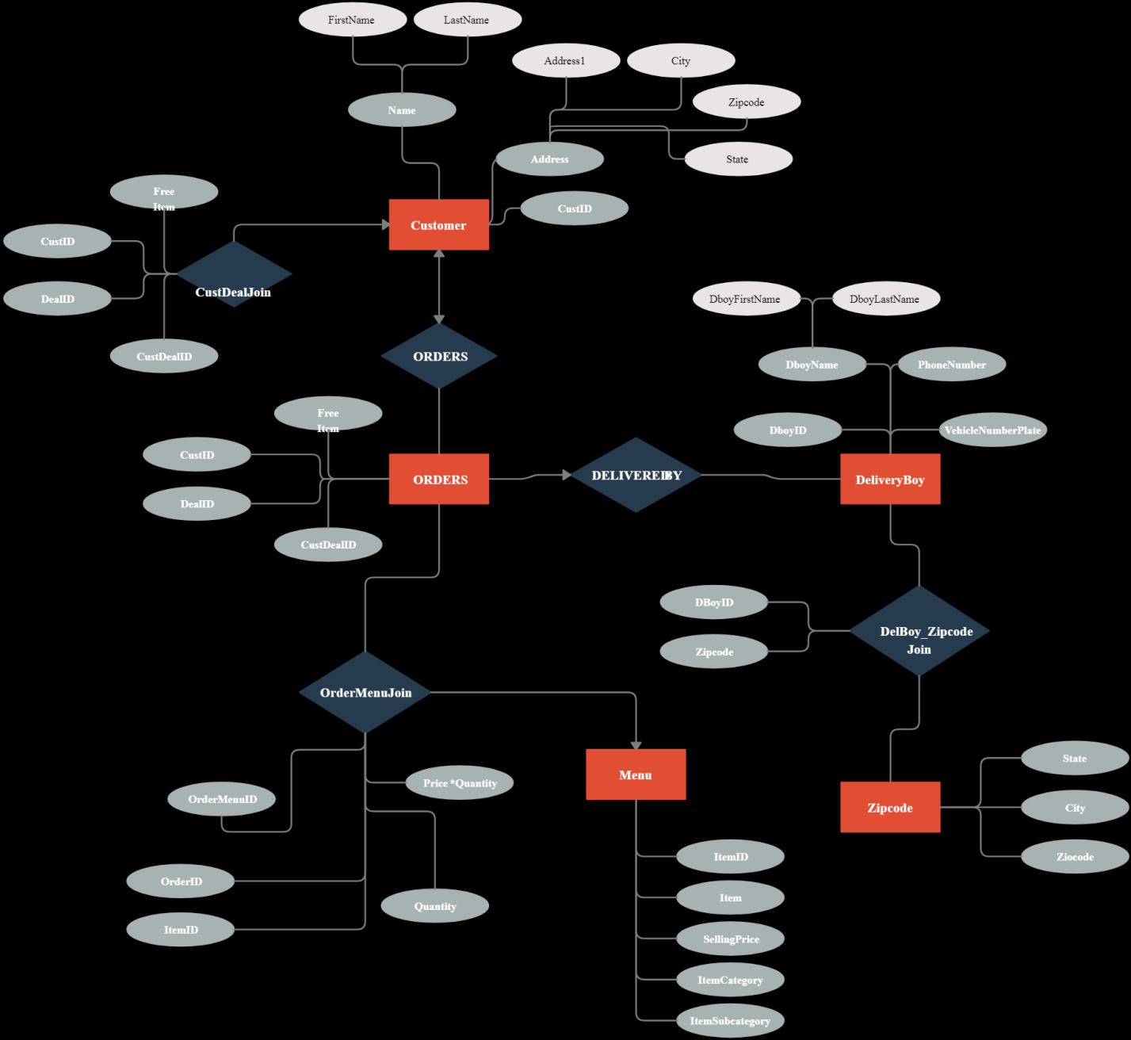

**SYSTEM MODEL**

**CONTEXT LEVEL DFD**

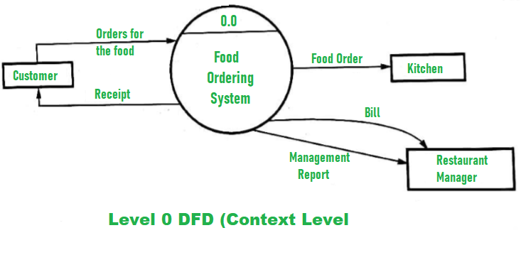

**FIRST LEVEL DFD**

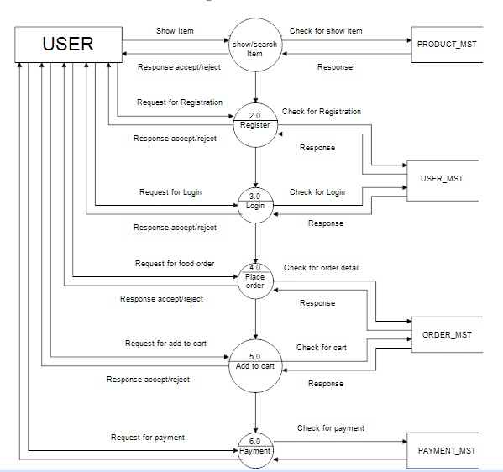

**DATA MODEL**

**TABLE DESIGN**

**Table Name-users**

This table stores the details of user.

|  |  |  |  |  |
| --- | --- | --- | --- | --- |
| **Field Name** | **Data Type** | **Field Size** | **Description** | **Constraints** |
| username | varchar | 255 | User id | Not null |
| password | text | 255 | User password | Not null |
| unnamed | varchar | 255 | User name | Not null |
| uemail | varchar | 255 | User email | Not null |
| uaddress | varchar | 255 | User address | Not null |
| ugender | varchar | 255 | User gender | Not null |
| uphone | varchar | 255 | User mobile no | Not null |
| ubirthdate | date | - | User birth date | Not null |
| uimg | text | - | User image | Not null |
| dt | varchar | 255 | User login date | Not null |
| srno | int | integer | Table id | Primary key |

**Table Name – Users1**

This table stores the details of food products.

|  |  |  |  |  |
| --- | --- | --- | --- | --- |
| **Field Name** | **Data Type** | **Field Size** | **Description** | **Constraints** |
| pid | int | integer | Product id | Not null |
| uid | varchar | 255 | User id | Not null |
| panme | varchar | 255 | Product name | Not null |
| pprice | varchar | 255 | Product price | Not null |
| pdescription | text | 255 | Product description | Not null |
| img | text | 255 | Product image | Not null |
| ptype | varchar | 255 | Product type | Not null |
| avil | int | integer | Product stoke | Not null |
| Making_time | text | 255 | Product making time | Not null |

**Table name- buy**

This table stores the details of orders.

|  |  |  |  |  |
| --- | --- | --- | --- | --- |
| **Field Name** | **Data Type** | **Field Size** | **Description** | **Constraints** |
| id | int | integer | Order id | Not null |
| busername | varchar | 255 | Oder user id | Not null |
| uquntity | int | 255 | Order quntity | Not null |
| baddress | varchar | 255 | Order address | Not null |
| **buytime** | date | - | Oderer time | Not null |
| pname | pname | 255 | Order product name | Not null |
| bprice | int | integer | Order product name | Not null |
| uid | int | integer | Order product id | Not null |
| P-type | text | 255 | Order payment type | Not null |
| pay | text | 255 | Order payment status | Not null |
| t-type | text | 255 | Order payment result | Not null |
| payid | text | 255 | Order Payment id | Not null |
| get-delivarey | text | 255 | Order deliverd empoylee id | Not null |
| time | timestamp | - | Order time | Not null |

**User display pages**

**Signup page**

**This is signup for user all entity is input.**

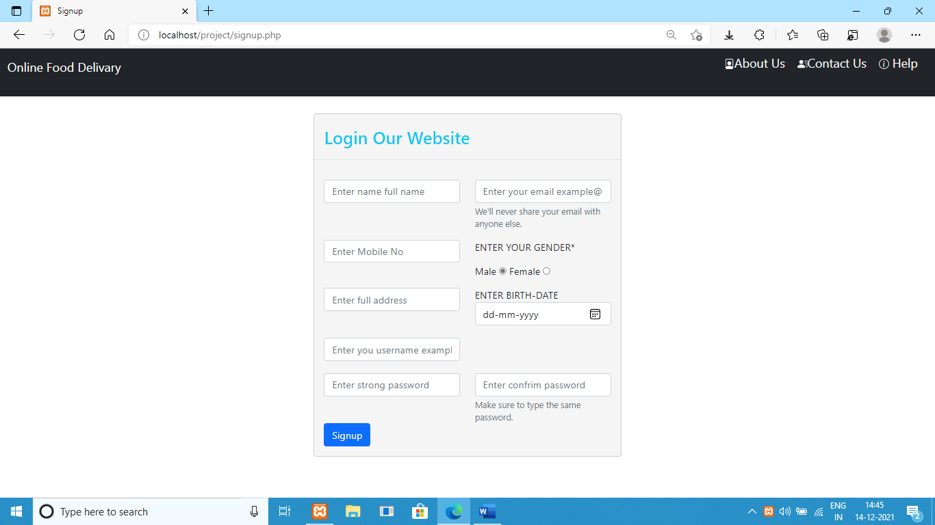

**Login page**

**This is login page for user that operates the system.**

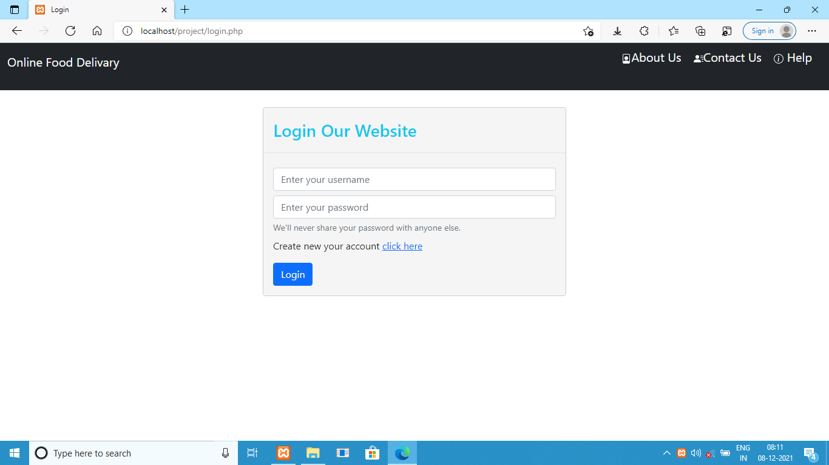

**Home page**

**This is the home page where all the information related to website is visible such as menus, about us, contact us, help, search bar, orders, profile, logout etc.**

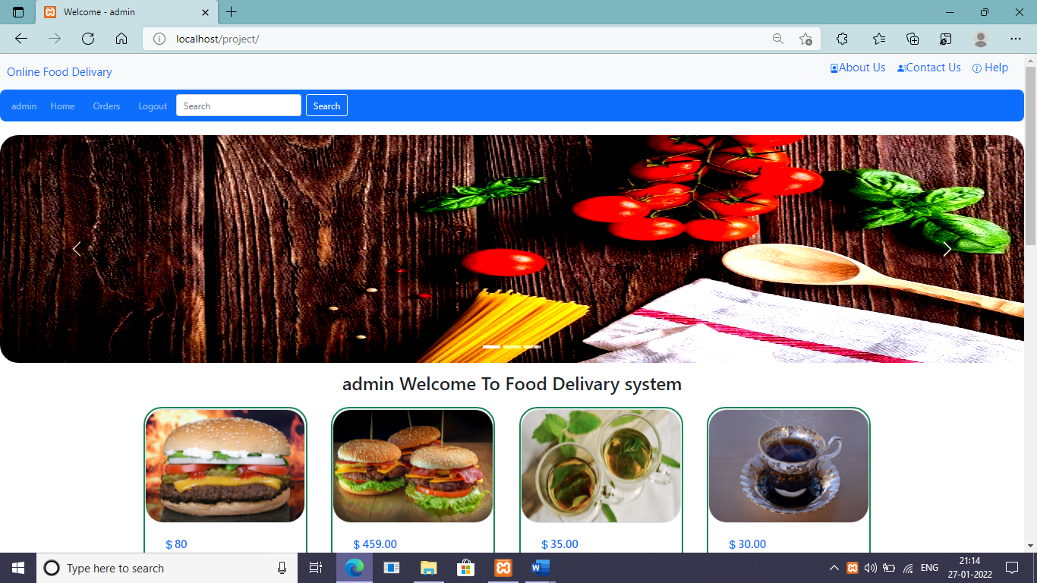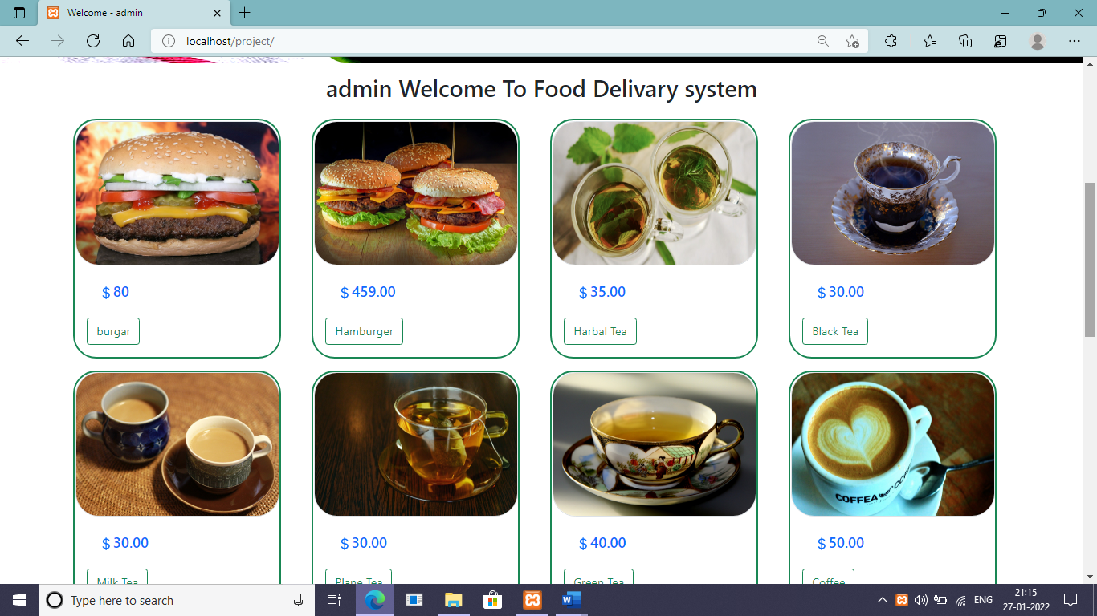

**Search bar**

**It is you needed food search**

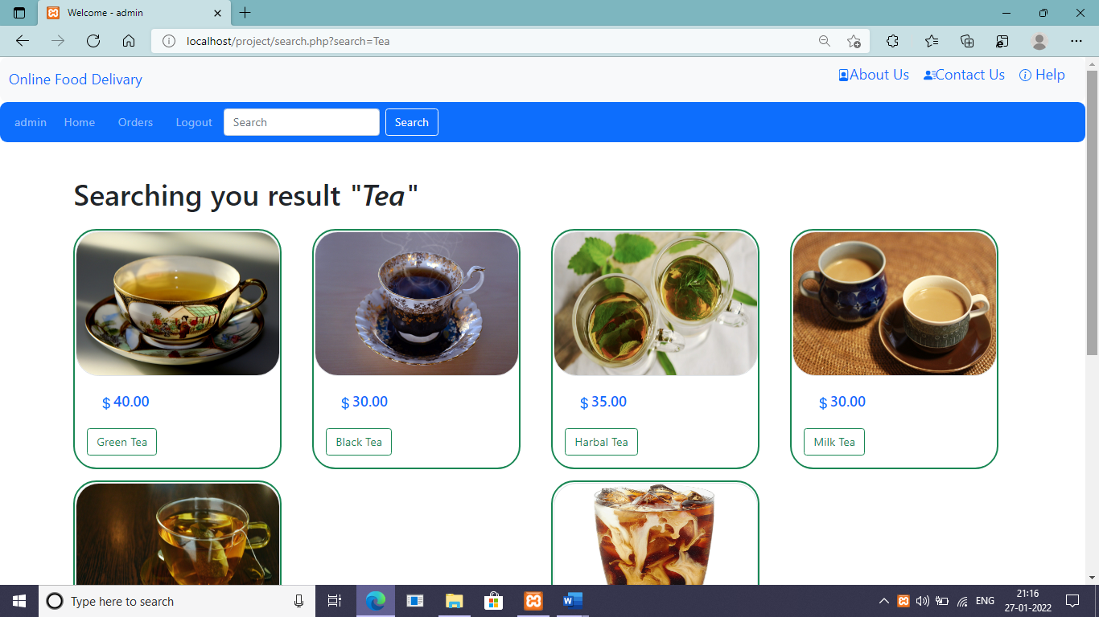

**My food**

**It is cart page it contains details about menu food.**

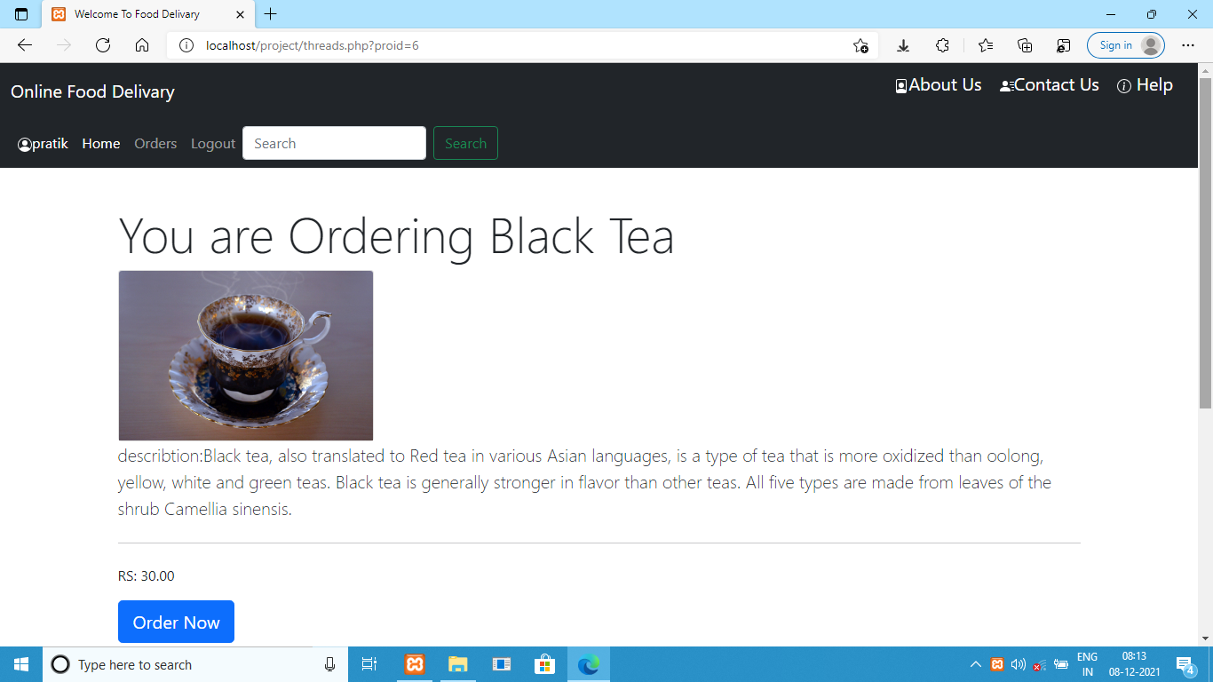

**Payment Confirmation**

**It I payment Confirmation page which contain information about payment details.**

**A menu is pay on delivery, mobile pay, debit/credit card.**

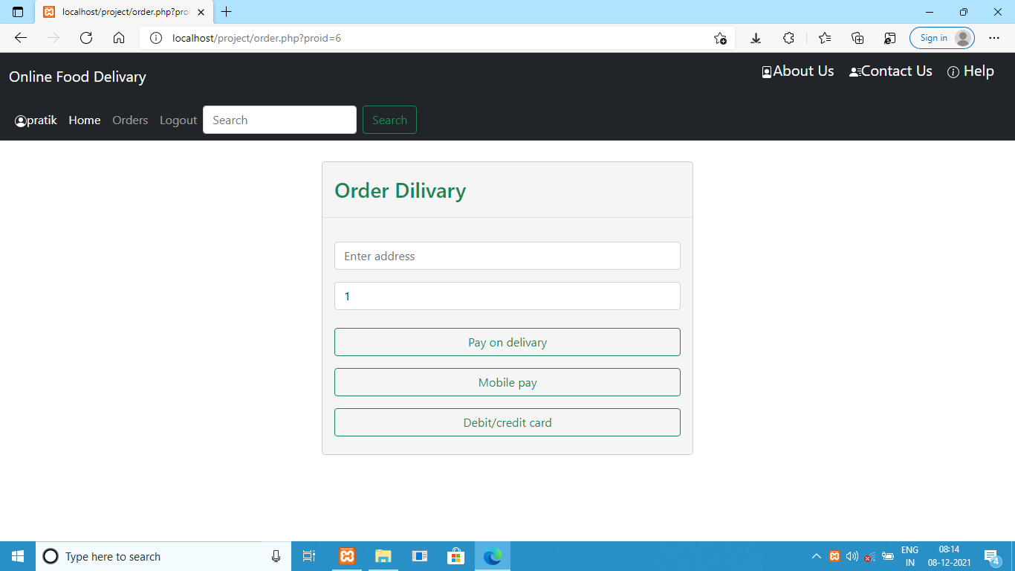

**Mobile pay page**

**This page is mobile scanner option for payment.**

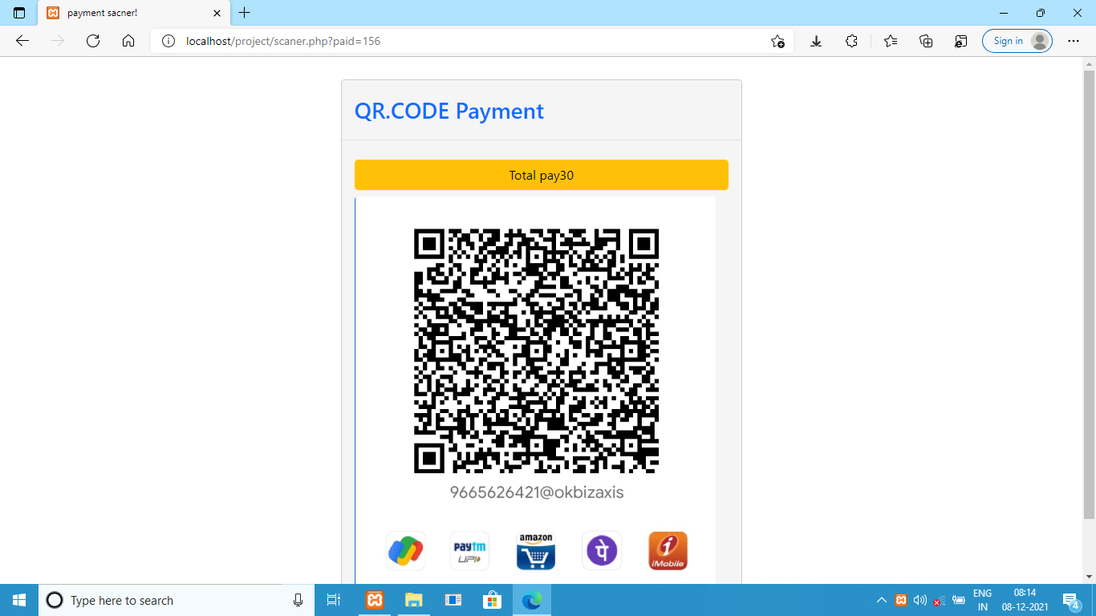

**Debit/credit card page**

**This page is made for debit/credit card payment an all-info input information to the card a keeping safe to user card payment.**

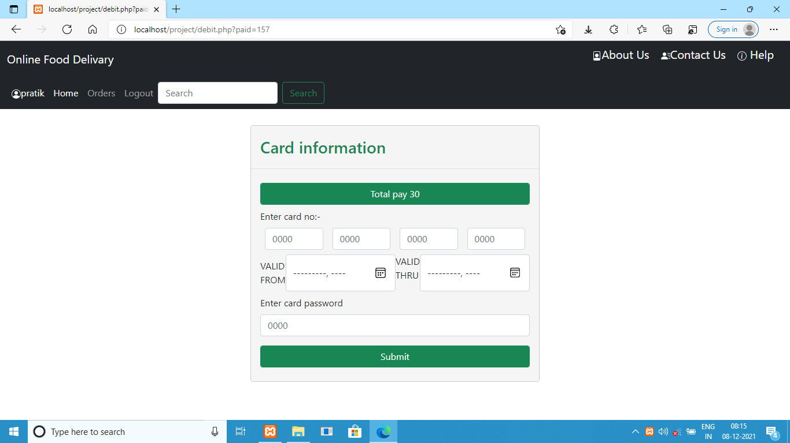

**Order success page**

**This page is indicated order result success or not a delivered time.**

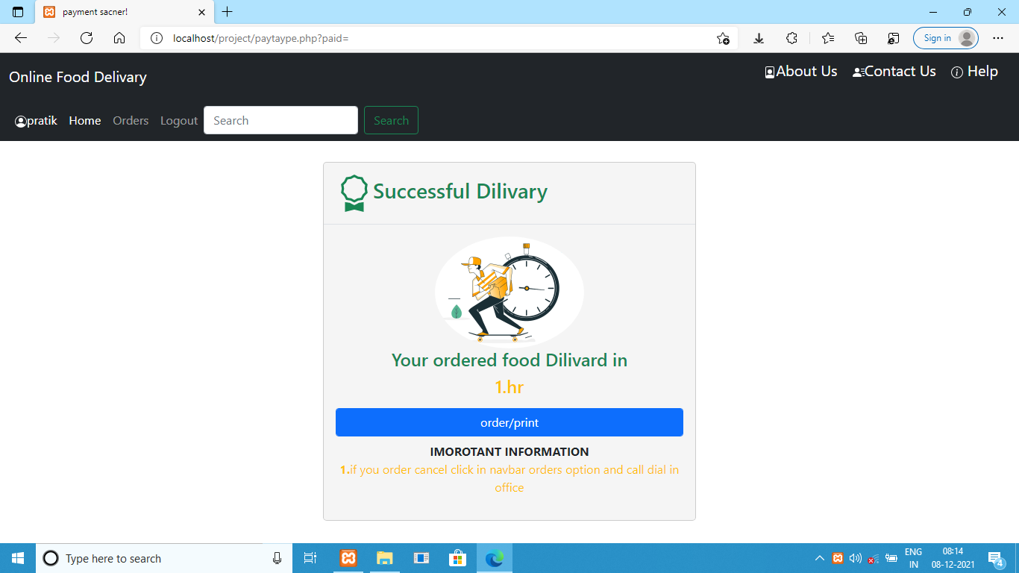

**Order history page**

**This page is storing all user-by-user order history an give the print option.**

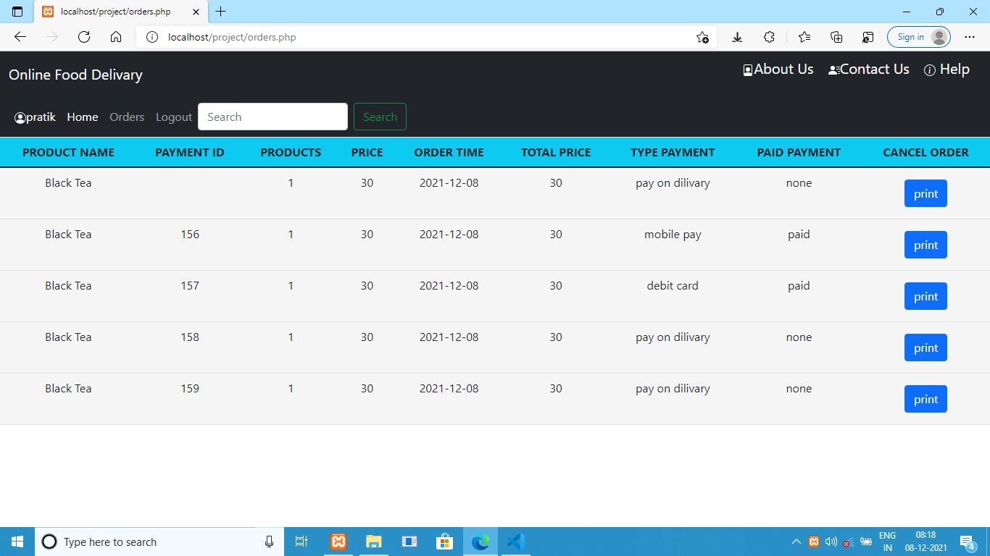

**Print page**

**This page is selected order all information are convert into A4 size page an give the print**

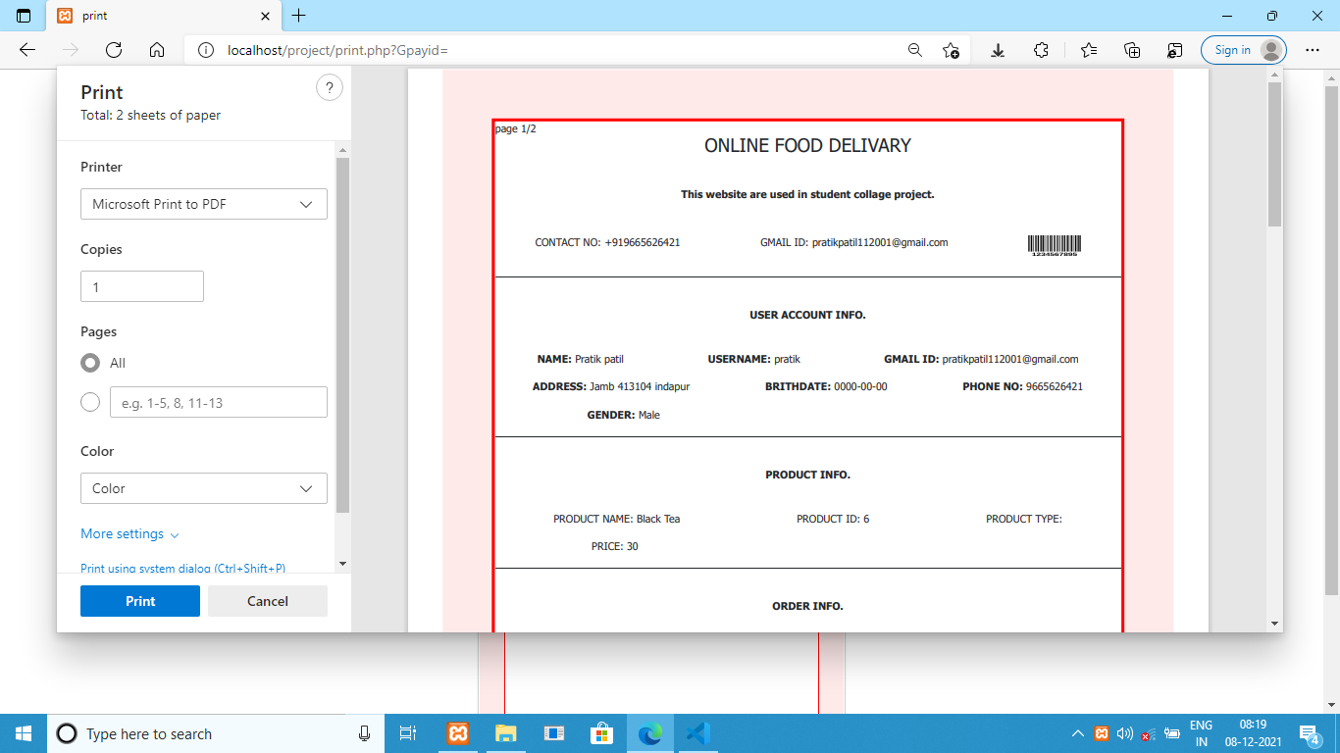

**Profile info page**

**This page is all particular user information are shows and their option is update profile, change password, delete account.**

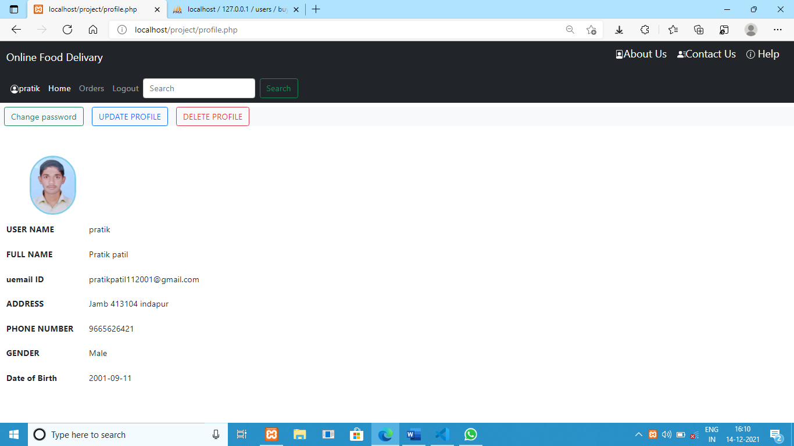

**Update profile page**

**This page is user information update**

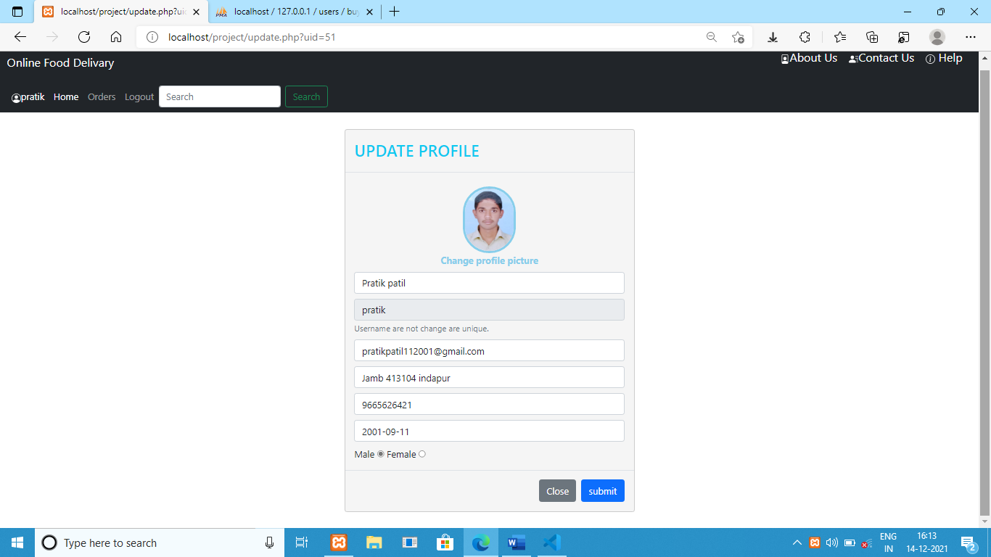

**Change password page**

**This page change password is keeping all intergraded security.**

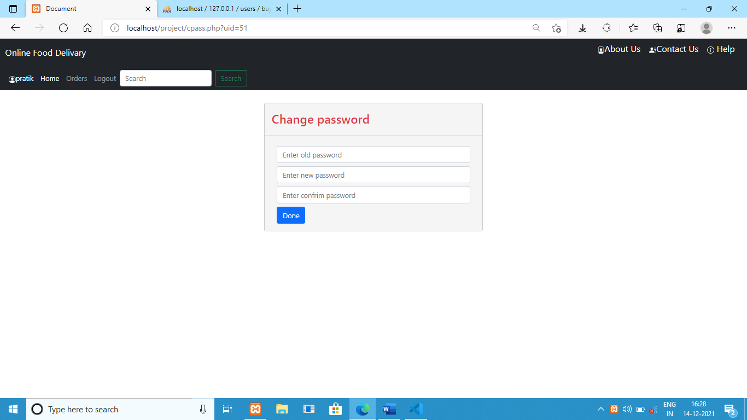

**About us**

**This page is all web information and guide the new user.**

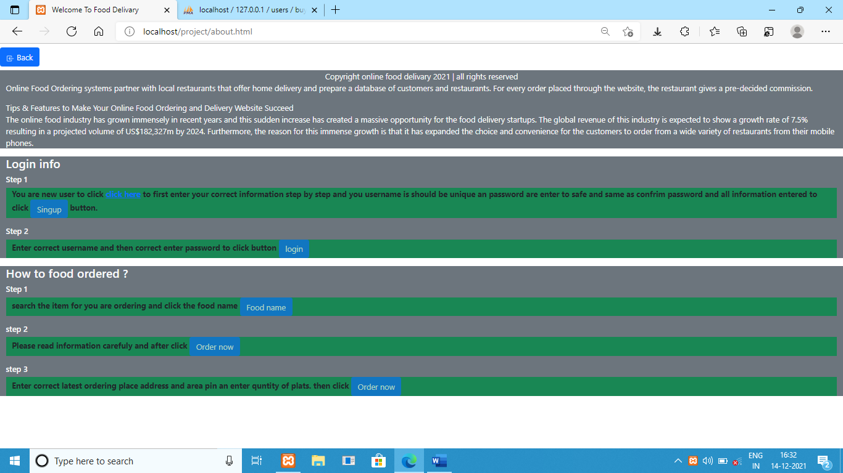

**Contact us**

**This page is the whole web-site admin contact info**

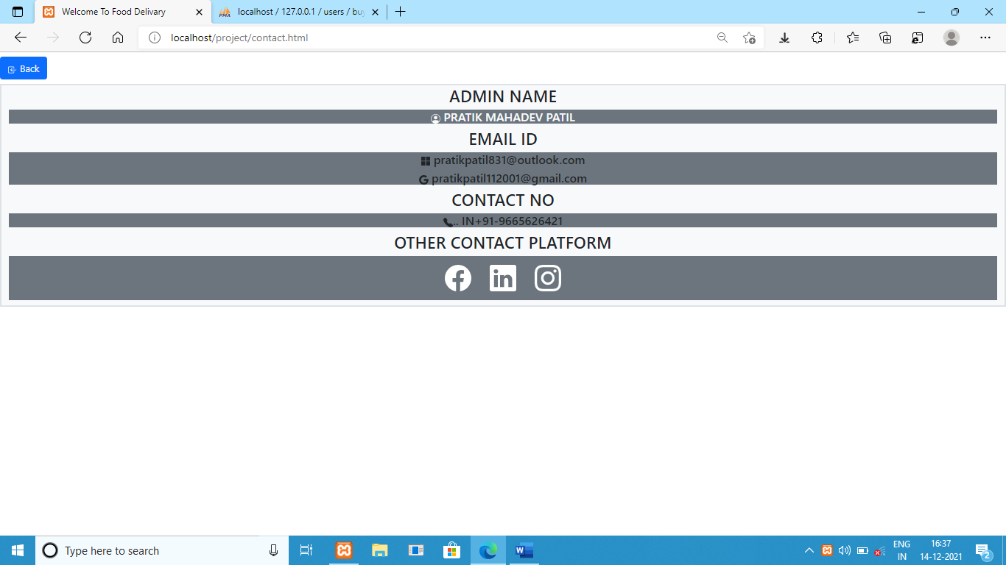

**Help page**

**This same as about page they all web information and guide the new user.**



**Admin display pages**

**Login page**

**This page is only entered to the admin an keeping all security.**

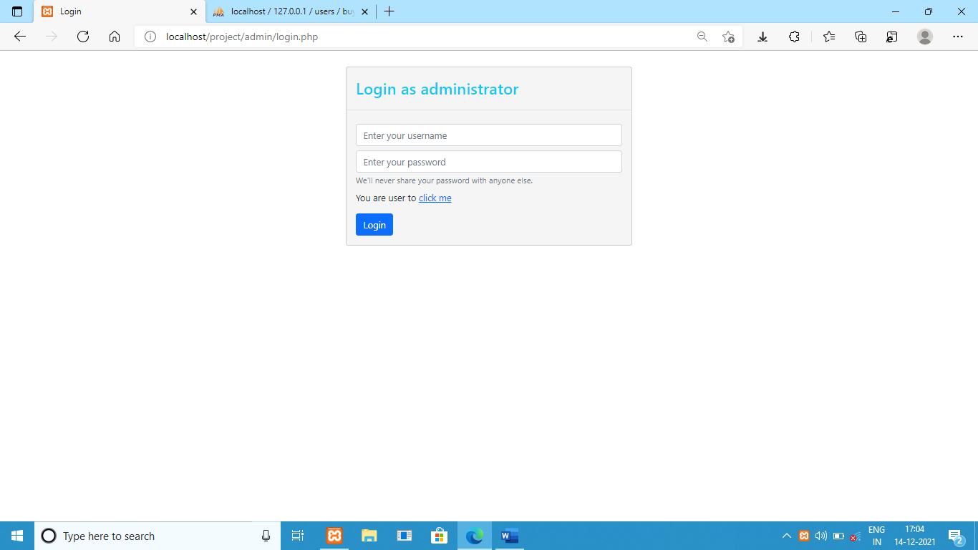

**Admin home page**

**This page is the all action for admin uses to the navigate is add product, view users, employee management, view orders, admin dashboard, logout and search bar a display employee payment, total order, total employee, total users and total earns, total products and admin all info.**

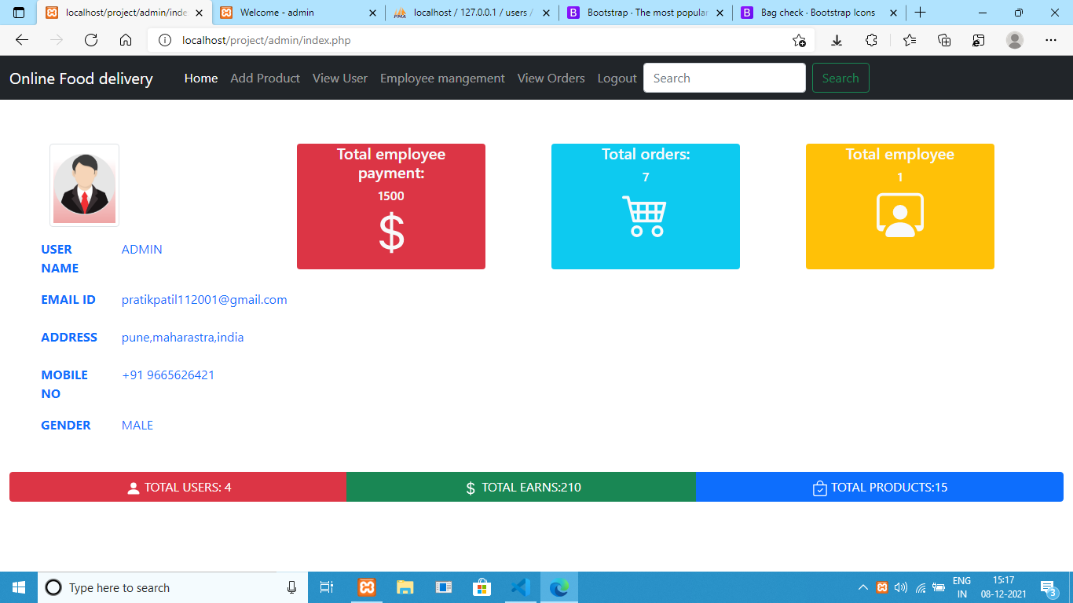

**Add product page**

**This page is adding the product all information a display product an update product.**

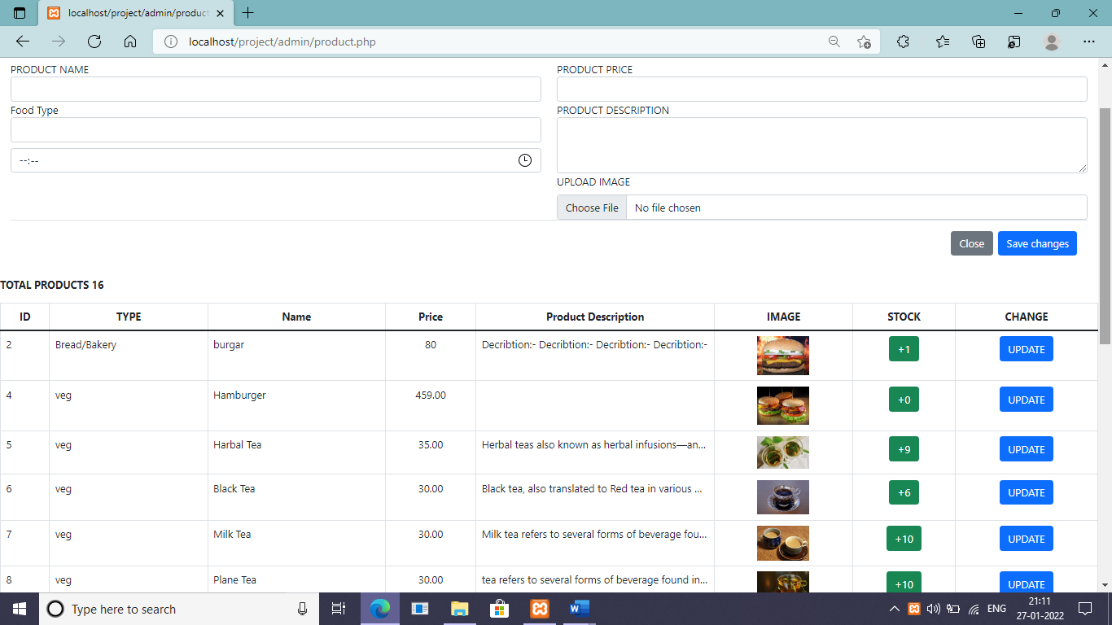

**Product update page**

**This page is updating all information as product.**

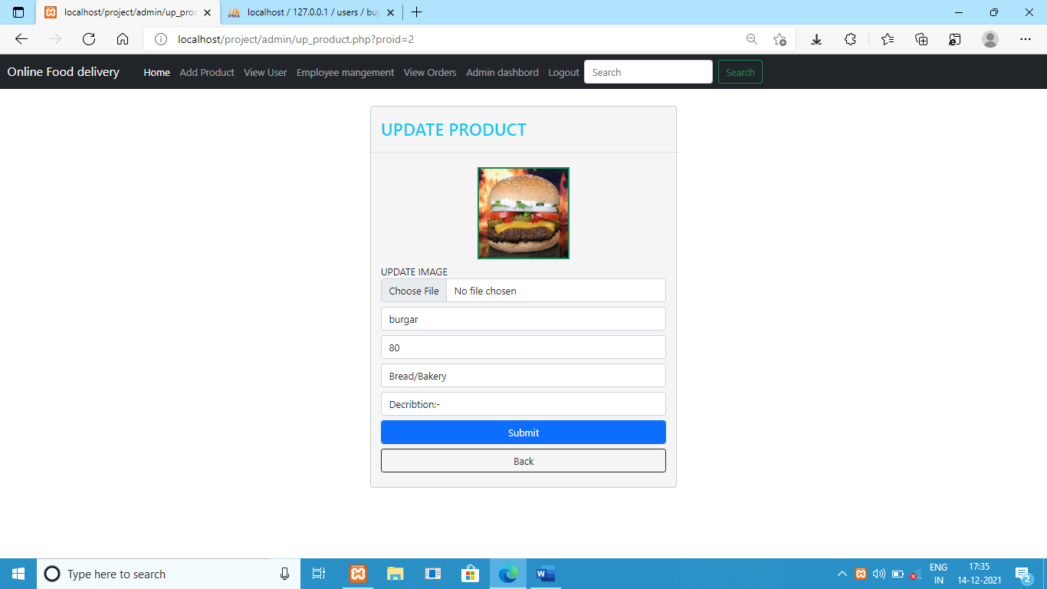

**View users page**

**This page is viewing all user a user information.**

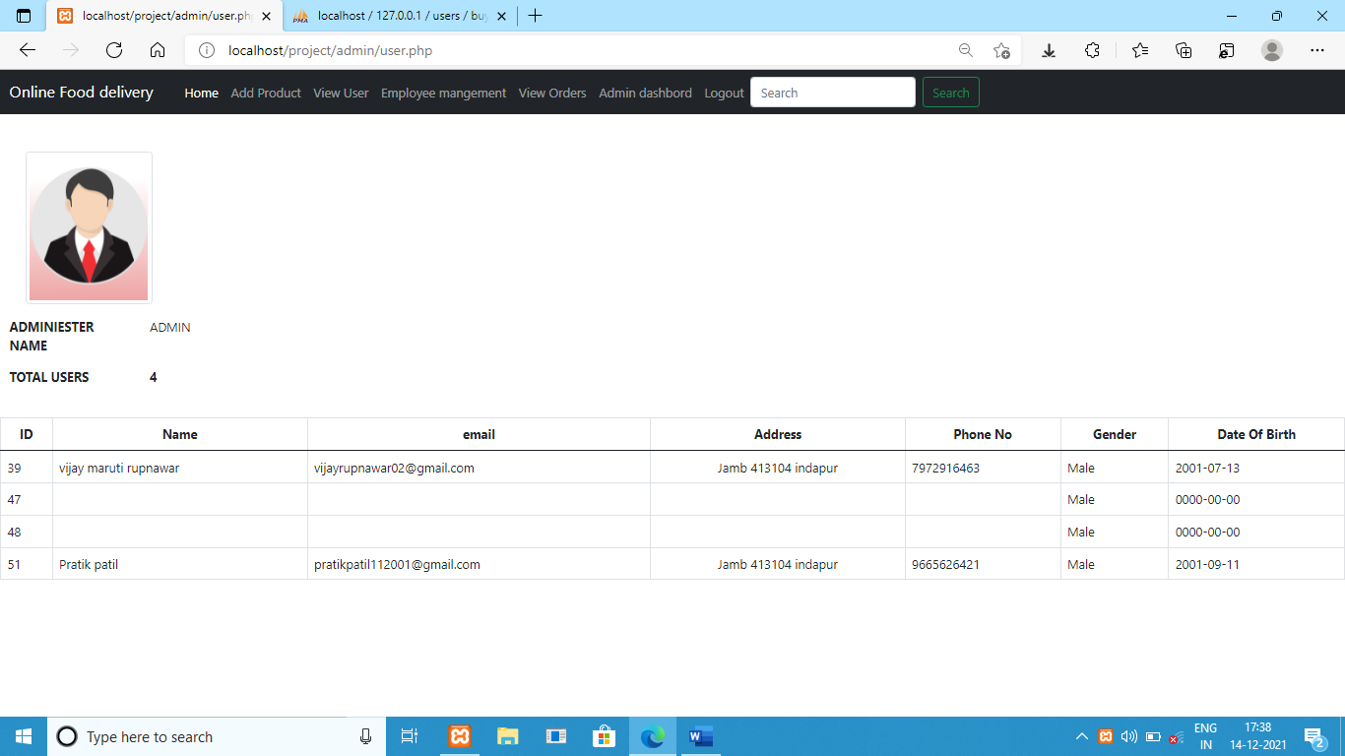

**Employee management page**

**This is viewing all employee information on the update employee, delete employee, add employee, input present/absent employee day by day information**

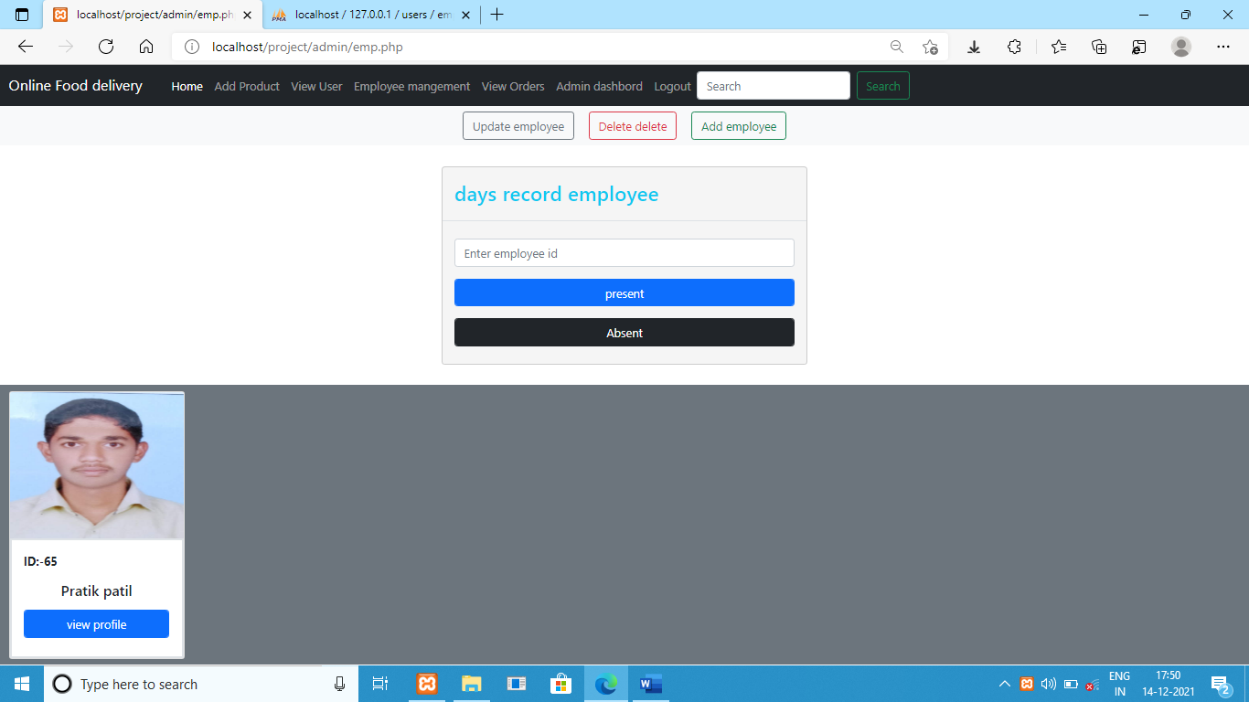

**Add employee page**

**This page is added new employee an input all information to uses to admin.**

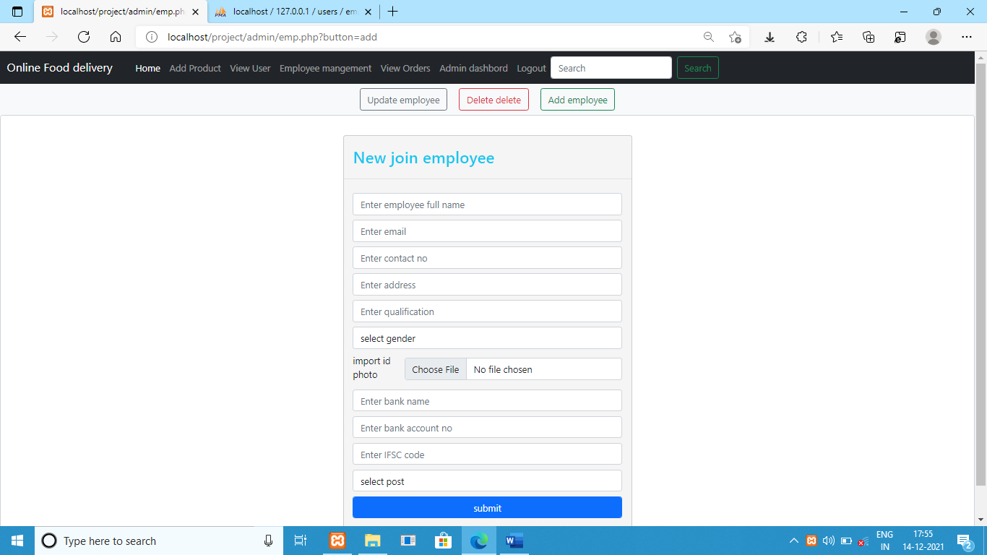

**Update employee page**

**This page is update employee information.**

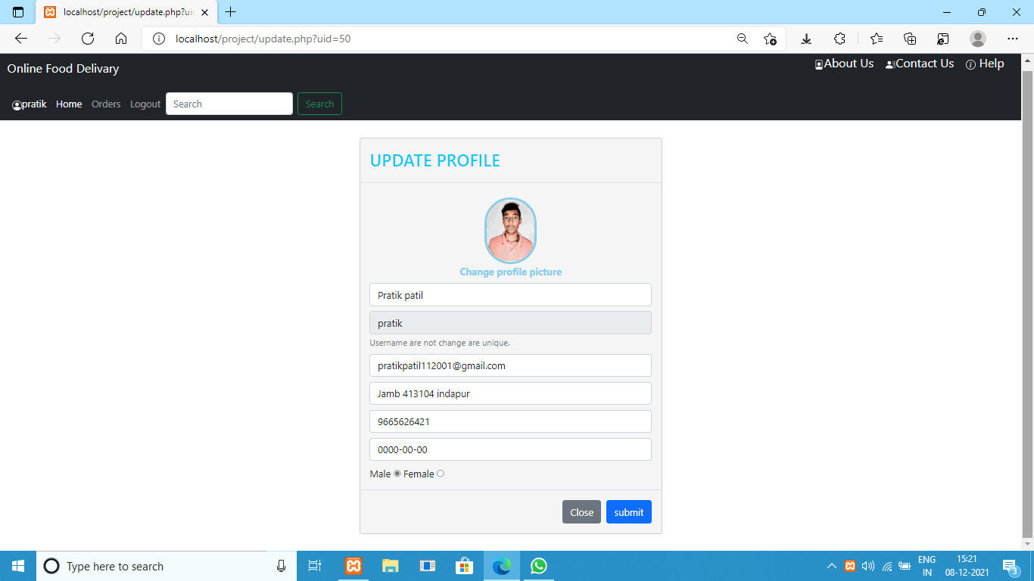

**View orders**

**This page is viewing all orders an get action to the order.**

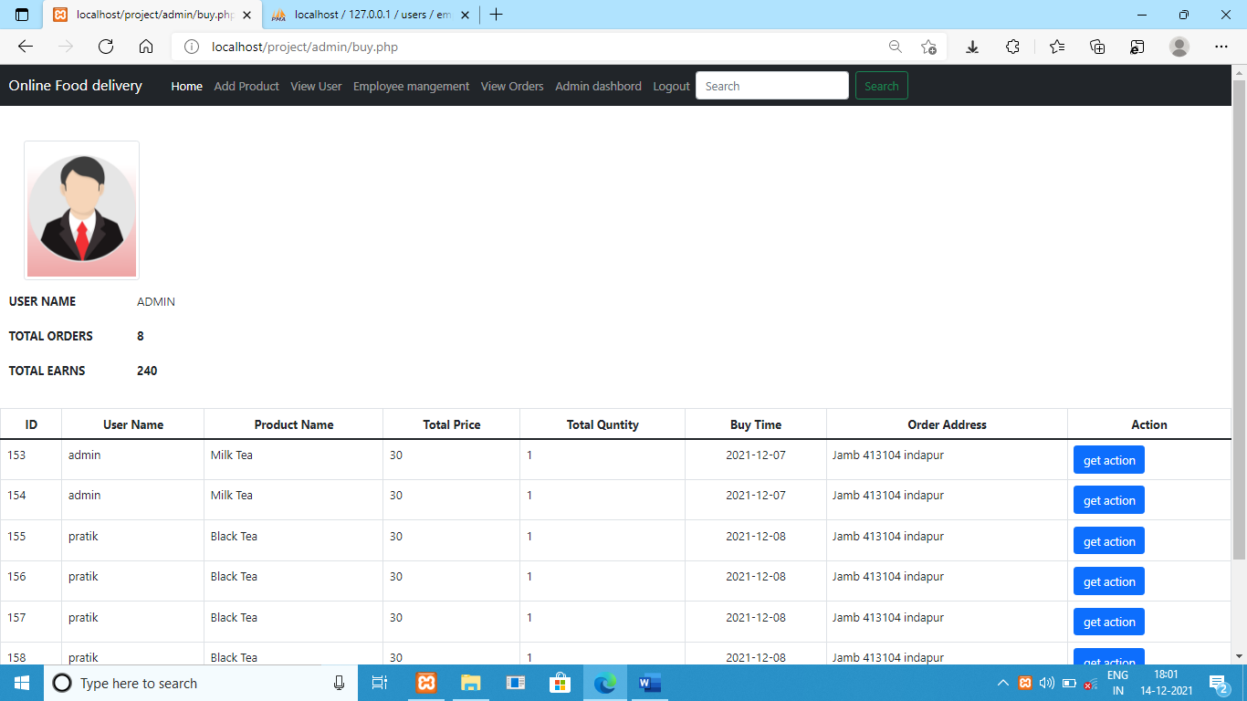

**Get action page**

**This is entered to order delivery boy id number.**

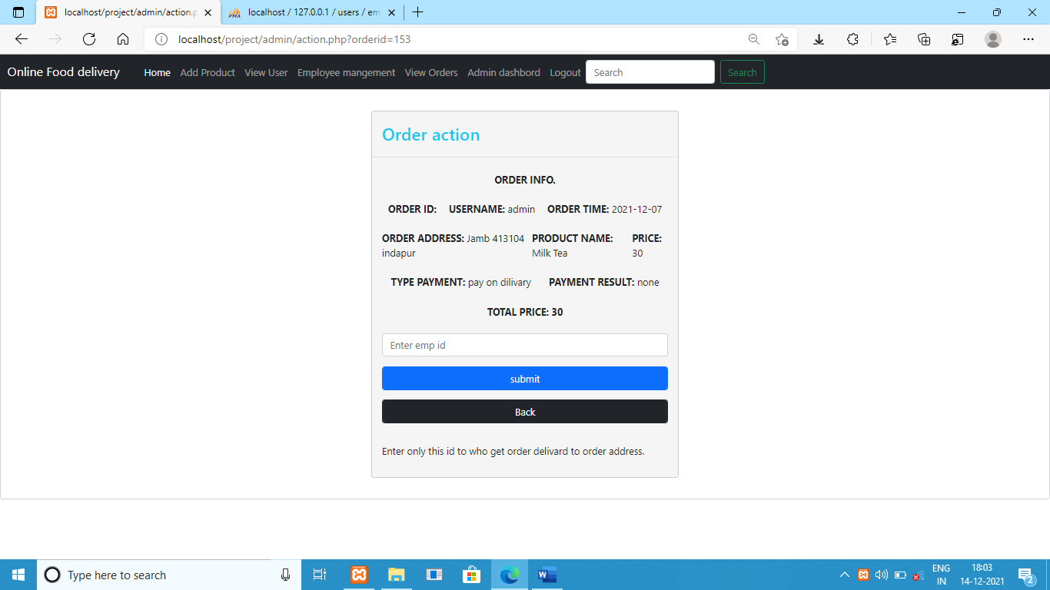

**Admin dashboard page**

**This page contains all orders display and their delivery boy id to confirm suitable for order delivery boy delivered order**

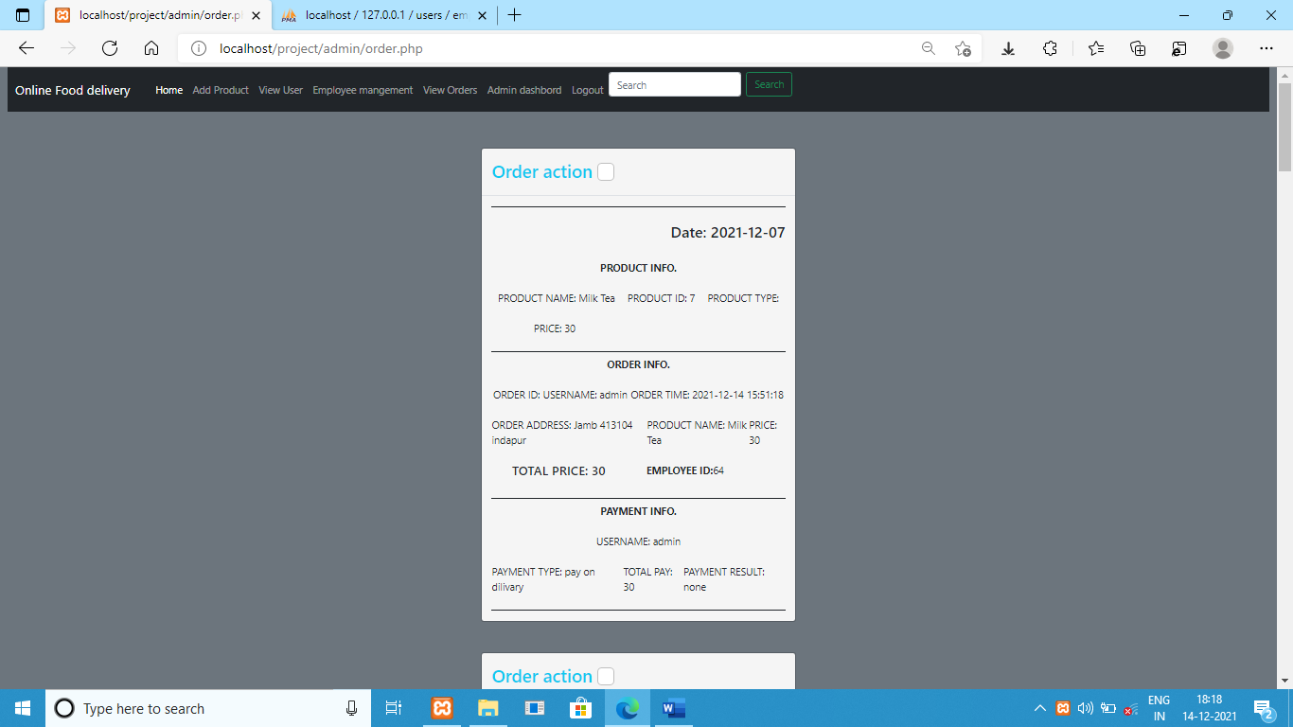

**SOFTWARE /HARDWARE SPECIFICATION**

**SOFTWARE REQUIREMENTS**

**Name of Project :** Online Food delivery System.

**Operating System** : Windows 7 or Higher version

**Language**              :PHP

**Databases used**      : MySQL

**Design used**       :HTML JavaScript, Ajax, jQuery, Bootstrap

**Browser used**          : Google Chrome, Opera Mozilla

**Software used**          : XAMPP

**HARDWARE REQUIREMENTS**

**CPU :** Pentium or Higher

**RAM :**128MB(Minimum)

**Hard Disk :**20GB

**TEST PLAN**

The purpose of system test is to see the overall performance of the system. The testing includes system installation, and performance checking. The major test results for this system testing are listed in the following table

|  |  |
| --- | --- |
| **System Tests Performed** | **Results** |
| **Black Box Testing**: | All the functionalities of this system work properly |
| **White Box Testing:** | Design and coding of this system are tested.  Verify flow of input-output operations. |
| **End to end testing** | Test the workflow from beginning to end of the system. |
| **Integration testing** | The entire integrated system meets the specified requirements. |
| **Performance testing** | It examines speed, stability, reliability of system. |
| **Acceptance Testing:** | Check Usability, functionality, and performance of this system. |
| **Installation Testing:** | system can be installed properly. |

## BLACK BOX TESTING

**Black Box Testing** is a software testing method in which the functionalities of software applications are tested without having knowledge of internal code structure, implementation details and internal paths. Black Box Testing mainly focuses on input and output of software applications and it is entirely based on software requirements and specifications. It is also known as Behavioral Testing.

|  |  |  |  |  |  |
| --- | --- | --- | --- | --- | --- |
| **Test code** | **Test case** | **Test Step** | **Expected result** | **Actual result** | **status**  **(Pass or**  **Fail)** |
| Test1 | Check administrator Login | Go to Login Page. Enter valid username and password.  Then Click on “login” | Successful Login | Login successful | Pass |
| Test 2 | Place order | Go to order placing Page. Check the menu details and select menu from it.  Then Click on “place order” | Placed order successfully | Placed order successfully | pass |
| Test3 | Check and verify customer order. | Go to order Page. Check the order details and verify it.  Then Click on “verify order” | Display message to customer that “your order is submitted” | Order is submitted | pass |
| Test4 | Customer Payment | Go to payment page. Select payment option then click on pay option. | Display message to customer that “your order is processed” | order is processed | pass |
|  | Test print out customer order data | Go to order page and click print customer order | The system can print and count the numbers correctly | Print customer order. | pass |

## WHITE BOX TESTING

**White Box Testing** is software testing technique in which internal structure, design and coding of software are tested to verify flow of input-output and to improve design, usability and security. In white box testing, code is visible to testers so it is also called Clear box testing, open box testing, transparent box testing, Code-based testing and Glass box testing.

|  |  |  |  |  |  |
| --- | --- | --- | --- | --- | --- |
| Test code | Test case | Test Step | Expected result | Actual result | status  (Pass or  Fail) |
| Test1 | Verify response when a valid username and password is used | Check the valid username and password that written in respective fields. | Successful Login | Login successful | Pass |
| Test 2 | Verify all decision-making statements | Check and verify all decision-making statements used in coding. | Verify successfully | Verify successfully | pass |
| Test3 | Verify all looping statements | Check and verify all looping statements used in coding. | Verify successfully | Verify successfully | pass |
| Test4 | Code optimization | Verify to remove repeated and extra code | Verify code optimization | Verify code optimization | pass |

**CONCLUSION**

This system is convenient, effective and easy thereby improving the performance of restaurants

staff. It will also provide quality of service and customer satisfaction. Overall conclusion is that,

this is a fabulous food ordering system for the restaurant sector, made by combining the wireless technology.

This system can accommodate to ease the user to order the menu categorized. So that, it will

fasten the process of ordering food until the orders are arrived in the kitchen and also it can minimize the mistake.

The promotion in the system can minimize the budget of the restaurant, since they do not have to print the brochures to inform about promotion that is held by the restaurant.

**RECOMMENDATIONS**

For further development, this application can be integrated for all types of mobile phones both

iOS and android and can download directly from the user's mobile application store, so users can

order food and book a place with the payment system at the beginning.

The system conversion suggestion uses parallel conversions, considering it avoids when a power

outage occurs and the system cannot run properly.

**FUTURE SCOPE**

**Security**: In terms of security purpose this work gives us the security alert as just like buzzer alarm.

**Multi-Touch Table**: Color tracking algorithm with the help of camera and projector it can make the multitouch table for interaction.

**Touch technology** can used in recently shopping malls, jeweler’s shops, and medical science field for the purpose of link with recent technology.

Use for Android Technology.

Order Ready notification: Send an Order Ready notification to the customer

Restaurant Locator: Allow to find and choose a nearby restaurant

Integrate with in store touch screen devices like iPad

BIBLIOGRAPHY

1. Google for problem solving
2. https://www.w3schools.com
3. <http://getbootstrap.com/>
4. 2.https://www.youtube.com
5. <http://www.javazoom.net/jzservlets/uploadbean/uploadbean.html>
6. <https://javabrains.io/>
7. <https://csveda.com/mini-projects/food-ordering-system-using-php-and-mysql/>
8. <https://pdfcoffee.com/php-project-on-online-food-ordering-system-pdf-free.html>
9. <https://www.freeprojectz.com/project-report/1778>